Laporan Tugas Modul 7

# Nama :DRISKA IAN P

# NIM :L200160016

Kelas :E Septimo Modulo

1. Script

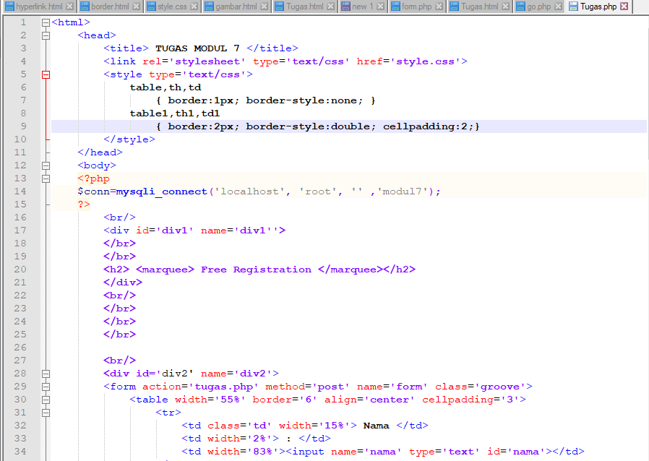

## 



.

|  |  |  |  |
| --- | --- | --- | --- |
| 37 | . | | <td class=’td’> Tgl Lahir |
| 38 | . | | <td> : </td> |
| 3S | - . | | <td><input name=’hr’ type=’text’ id=’hr’ size=’4’ maxlenght=’2’>/ |
| 40 | . | | <input name=’bIn’ type=’text’ id=’bIn’ size=’4’ maxlenght=’2’>/ |
| 41 | . | | <input name=’thn’ type=’text’ id=’thn’ size=’8’ maxlenght=’4’> |
| 42 |  | . </td> | |
| 43 |  | </tr> | |
| 44 | - | <tr> | |
| 45 |  | <td class='td'> Alamat </td> | |
| 46 |  | <td> &mbsp; </td> | |
| 47 |  | <td><teztarea name=’aIamat’ cols=’4O’ rows=’2’ id=’aIamat’></teztarea></td> | |
| 48  4 S  50 | - | </tr>  <tr>  <td class=’td’ width=’I5%’> Aota </td> | |
| 51 |  | <td> : </td> | |
| 52 |  | <td><input name=’kota’ type=’text’ id=’kota’></td> | |
| 53 |  | </tr> | |
| 54 | - | <tr> | |
| 55 |  | <td> &mbsp; </td> | |
| 56 |  | <td> &mbsp; </td> | |
| 57 | - | <td> <input type=’submit’ id=’kirim’ Palue=’Kirim’> | |
| 58 |  | <input name=’canceI’ type=’reset’ id='btnCanceI’ Palue=’CanceI’> | |
| 55 |  | </td> | |
| 60 |  | </tr> | |
| 61 |  | </table> | |
| 62 |  | </form> | |

.

65 Snama=S_PO9T[’nama’];

## cc shr=s_eosi[’R ’;:

1. Sbln=S Po9T[’bin’];
2. Sthn=S Pose[’thn’]; 6S

70 Saiamat=S PO9T[’alamat’];

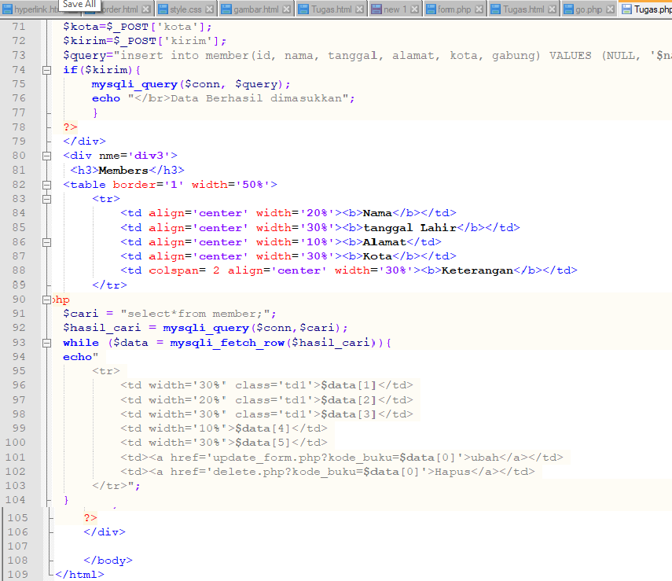

# Preview Main Page

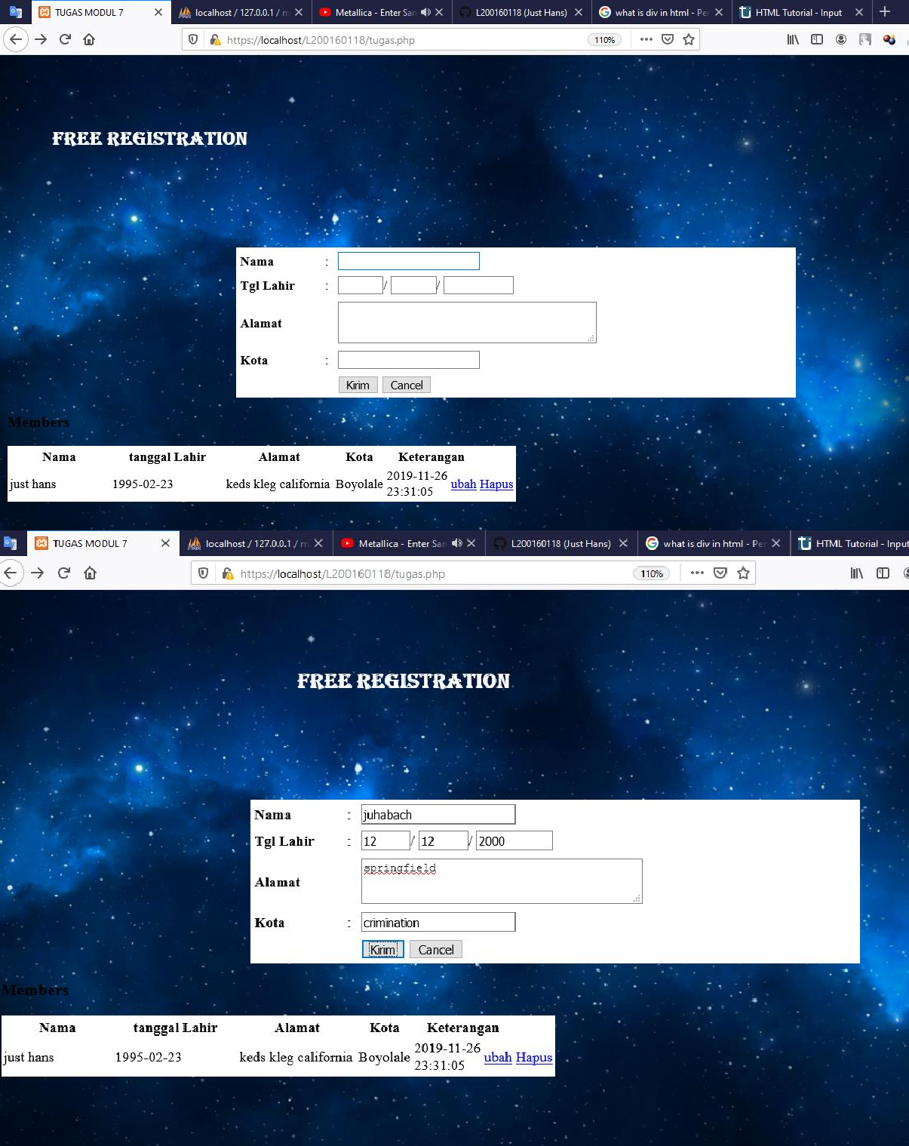

Hasil

